**LAB 3**

1.Create a superclass Person with attributes name and age, and a method display(). Create a subclass Student that adds an attribute studentID. Write a program to create a Student object and display all its attributes.

**INPUT:**

**package** Hellow; //This is my package

//Superclass Person

**class** Person {

// Attributes

**protected** String name;

**protected** **int** age;

// Constructor

**public** Person(String name, **int** age) {

**this**.name = name;

**this**.age = age;

}

// Method to display information

**public** **void** display() {

System.***out***.println("Name: " + name);

System.***out***.println("Age: " + age);

}

}

//Subclass Student inheriting from Person

**class** Student **extends** Person {

**private** **int** studentID;

// Constructor

**public** Student(String name, **int** age, **int** studentID) {

**super**(name, age);

**this**.studentID = studentID;

}

// Method to display student information, overriding display() from Person

@Override

**public** **void** display() {

**super**.display(); // Call superclass display method

System.***out***.println("Student ID: " + studentID);

}

}

//StudentID class to demonstrate usage

**public** **class** StudentID {

**public** **static** **void** main(String[] args) {

Student student = **new** Student("Anjali Singh", 20, 64021);

// Displaying all attributes of the Student

student.display();

}

}

**Output:**

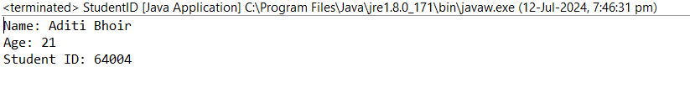

2.     Create a superclass Calculator with a method add(int a, int b). Create a subclass AdvancedCalculator that overloads the add method to handle three integers.

**INPUT:**

**package** EDemo;

//Superclass Calculator

**class** Calculator {

// Method to add two integers

**public** **int** add(**int** a, **int** b) {

**return** a + b;

}

}

//Subclass AdvancedCalculator inheriting from Calculator

**class** AdvancedCalculator **extends** Calculator {

// Overloading the add method to handle three integers

**public** **int** add(**int** a, **int** b, **int** c) {

**return** a + b + c;

}

}

//Main class to demonstrate usage

**public** **class** Calculator2 {

**public** **static** **void** main(String[] args) {

Calculator basicCalc = **new** Calculator();

AdvancedCalculator advancedCalc = **new** AdvancedCalculator();

// Using the add methods

**int** sum1 = basicCalc.add(10, 20); // Uses Calculator's add method

**int** sum2 = advancedCalc.add(10, 20, 30); // Uses AdvancedCalculator's add method

System.***out***.println("Sum using basic calculator: " + sum1);

System.***out***.println("Sum using advanced calculator: " + sum2);

}

}

**Output:**

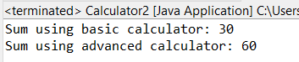

3.     Create a superclass Vehicle with a method move(). Create subclasses Car and Bike that inherit from Vehicle. Write a program to create objects of Car and Bike and call the move() method on each.

**INPUT:**

**package** Hellow;

//first Creating a Superclass

**class** Vehicle {

**public** **void** move() {

System.***out***.println("Vehicle is moving");

}

}

**class** Car **extends** Vehicle { //Subclass Bike extends Vehicle

**public** **void** move() {

System.***out***.println("Car is moving");

}

}

**class** Bike **extends** Vehicle { //Subclass Bike extends Vehicle

**public** **void** move() {

System.***out***.println("Bike is moving");

}

}

**public** **class** Vahicle2{

**public** **static** **void** main(String[] args) {

//Calling move mehod by makuing oblecvt of classes

Vehicle car = **new** Car();

Vehicle bike = **new** Bike();

car.move();

bike.move();

}

}

**Output:**

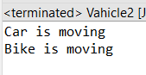

4. Create an class Employee with an abstract method calculatePay(). Create subclasses SalariedEmployee and HourlyEmployee that implement the calculatePay() method. Write a program to create objects of both subclasses and call the calculatePay() method.

**INPUT:**

**package** EDemo;

//Abstract superclass Employee

**abstract** **class** Employees {

**public** **abstract** **void** calculatePay(); // Abstract method far calculate and pay

}

**class** SalariedEmployee **extends** Employees {

**public** **void** calculatePay() {

System.***out***.println("Calculating salary for a salaried employee. !");

}

}

//Subclass HourlyEmployee

**class** HourlyEmployee **extends** Employees {

**public** **void** calculatePay() {

System.***out***.println("Calculating pay for an hourly employee !");

}

}

**public** **class** CalculatePays {

**public** **static** **void** main(String[] args) {

Employees salariedEmp = **new** SalariedEmployee();

Employees hourlyEmp = **new** HourlyEmployee();

salariedEmp.calculatePay(); //calling methods

hourlyEmp.calculatePay();

}

}

**Output:**

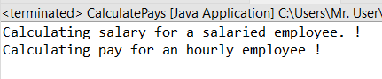

5. Create an class Document with an method void open(). Implement subclasses WordDocument, PDFDocument, and SpreadsheetDocument that extend Document and provide implementations for open(). Write a main class to demonstrate opening different types of documents.(implement complile time- polymorphism).

**INPUT:**

**package** Hellow;

**class** Document {

// Method to open document (to be overridden by subclasses)

**public** **void** open() {

System.***out***.println("Opening a generic document");

}

}

//Sub claases

**class** WordDocument **extends** Document {

**public** **void** open() {

System.***out***.println("Opening a Word document");

}

}

**class** PDFDocument **extends** Document {

**public** **void** open() {

System.***out***.println("Opening a PDF document");

}

}

**class** SpreadsheetDocument **extends** Document {

**public** **void** open() {

System.***out***.println("Opening a Spreadsheet document");

}

}

**public** **class** OfficeDoc {

**public** **static** **void** main(String[] args) {

Document doc1 = **new** WordDocument();

Document doc2 = **new** PDFDocument();

Document doc3 = **new** SpreadsheetDocument();

//calling the method from classes

doc1.open();

doc2.open();

doc3.open();

}

}

**Output:**

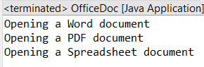

6. Create a class Calculator with overloaded methods add() that take different numbers and types of parameters: int add(int a, int b), double add(double a, double b), int add(int a, int b, int c) Write a main class to demonstrate the usage of these methods.

**INPUT:**

**package** Hellow;

//creating a Class with overloaded add methods

**class** Calculat {

//Method to add two integers

**public** **int** add(**int** a, **int** b) {

**return** a + b;

}

//Method for add two doubles

**public** **double** add(**double** a, **double** b) {

**return** a + b;

}

//Method for add three integers

**public** **int** add(**int** a, **int** b, **int** c) {

**return** a + b + c;

}

}

**public** **class** CalculateLab {

**public** **static** **void** main(String[] args) {

Calculat calc = **new** Calculat();

//Demonstrate adding two integers

**int** sum1 = calc.add(5, 10);

System.***out***.println("Sum of 5 and 10 (int): " + sum1);

**double** sum2 = calc.add(10.5, 20.5);

System.***out***.println("Sum of 10.5 and 20.5 (double): " + sum2);

**int** sum3 = calc.add(5,10,15);

System.***out***.println("Sum of 5, 10, and 15 (int): " + sum3);

}

}

**Output:**

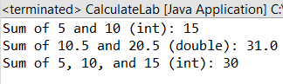

7. Create a JavaBean class Person with properties firstName, lastName, age, and email. Implement the required no-argument constructor, getter and setter methods for each property. Write a main class to create an instance of Person, set its properties, and print them out.

**INPUT:-**

**package** EDemo;

**import** java.io.Serializable;

**class** Person **implements** Serializable {

**private** String firstName;

**private** String lastName;

**private** **int** age;

**private** String email;

// creatingg constructor

**public** Person() {

}

// Getter and Setter for firstName

**public** String getFirstName() {

**return** firstName;

}

**public** **void** setFirstName(String firstName) {

**this**.firstName = firstName;

}

// Getter and Setter for lastName

**public** String getLastName() {

**return** lastName;

}

**public** **void** setLastName(String lastName) {

**this**.lastName = lastName;

}

// Getter and Setter for age

**public** **int** getAge() {

**return** age;

}

**public** **void** setAge(**int** age) {

**this**.age = age;

}

// Getter and Setter for email

**public** String getEmail() {

**return** email;

}

**public** **void** setEmail(String email) {

**this**.email = email;

}

}

**public** **class** inheritanceDemo {

**public** **static** **void** main(String[] args) {

// Create an instance of Person

Person person = **new** Person();

person.setFirstName("Anjali");

person.setLastName("Singh");

person.setAge(22);

person.setEmail("Singh91104@gmail.com");

System.***out***.println("First Name: " + person.getFirstName());

System.***out***.println("Last Name: " + person.getLastName());

System.***out***.println("Age: " + person.getAge());

System.***out***.println("Email: " + person.getEmail());

}

}

**Output:-**

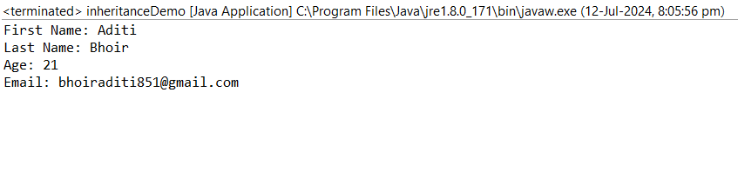

8. Create a JavaBean class Car with properties make, model, year, and color. Implement the required no-argument constructor, getter and setter methods for each property. Write a main class to create an instance of Car, set its properties, and print the car details.

**INPUT:**

**package** EDemo;

**import** java.io.Serializable;

**class** Cars **implements** Serializable {

**private** String make;

**private** String model;

**private** **int** year;

**private** String color;

**public** Cars() {}

**public** String getMake() {

**return** make;

}

// Setter for make

**public** **void** setMake(String make) {

**this**.make = make;

}

// Getter for model

**public** String getModel() {

**return** model;

}

// Setter for model

**public** **void** setModel(String model) {

**this**.model = model;

}

// Getter for year

**public** **int** getYear() {

**return** year;

}

// Setter for year

**public** **void** setYear(**int** year) {

**this**.year = year;

}

// Getter for color

**public** String getColor() {

**return** color;

}

// Setter for color

**public** **void** setColor(String color) {

**this**.color = color;

}

}

**public** **class** Javabean { // main class

**public** **static** **void** main(String[] args) {

// Create an object of Car

Cars car = **new** Cars();

// Seting thepropeerties of car

car.setMake("Tata");

car.setModel("Nexon");

car.setYear(2024);

car.setColor("Blue");

System.***out***.println("Car Make: " + car.getMake());

System.***out***.println("Car Model: " + car.getModel());

System.***out***.println("Car Year: " + car.getYear());

System.***out***.println("Car Color: " + car.getColor());

}

}

**Output:**

